# Lab 5. Simulation electrical systems dynamic

**Name: Li Xin**

**ITMO ID: 375334**

## Specialization: Automation

## Objective

Familiarize yourself with the methods for determining the parameters of the model by frequency characteristics using the example of electrical circuits.

## Initial data

An electric filter is given, the circuit of which is shown in Figure 1. The input signal of the filter is EMF *E*, and the output signal is voltage *UR* . The frequency response is also given in the form of a data set for the options (Figure 2a) and the response to the step signal of EMF *E* (Figure 2b) to verify the results of identifying the parameters of the electric filter model.

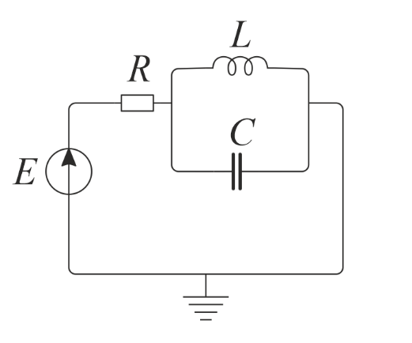

Figure 1. Electric filter equivalent circuit.

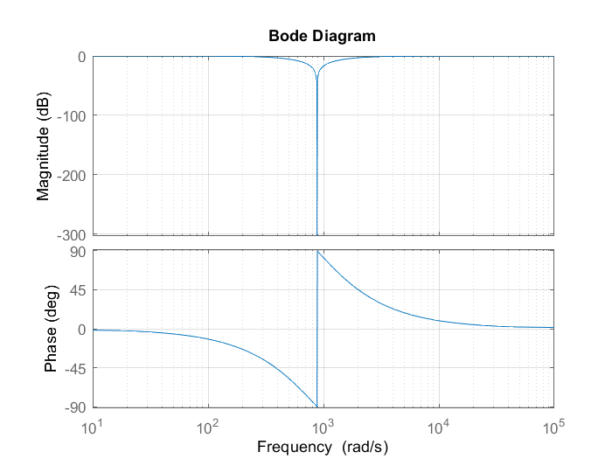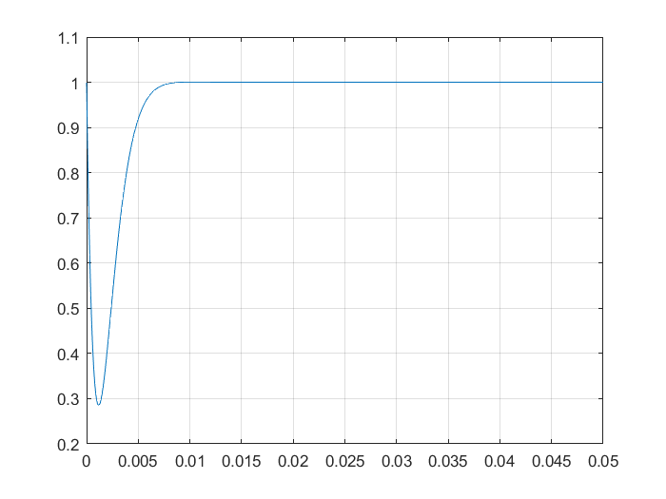

a) b)

Figure 2. Frequency response of voltage UR (a) and response to the step signal of EMF *E* (b).

**1. Build a simulation circuit.**



**Figure 1.** Equivalent circuit.

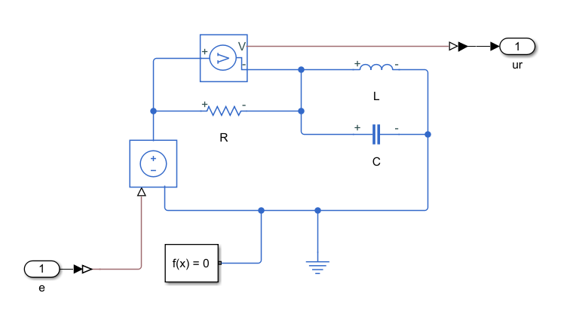

**Figure 2.** Simulation circuit.

**2. Component equations.**

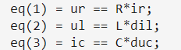

**3. Topological equations.**

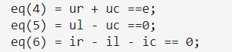

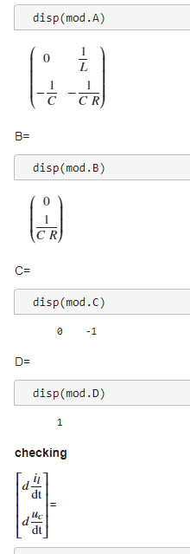**4. State-space model.**

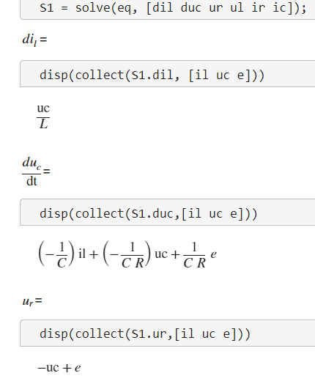

**5. Transfer function.**

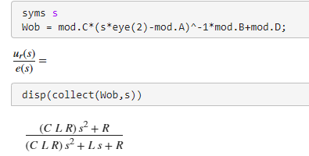

**6. Calculation of R, L and C using frequency response.**

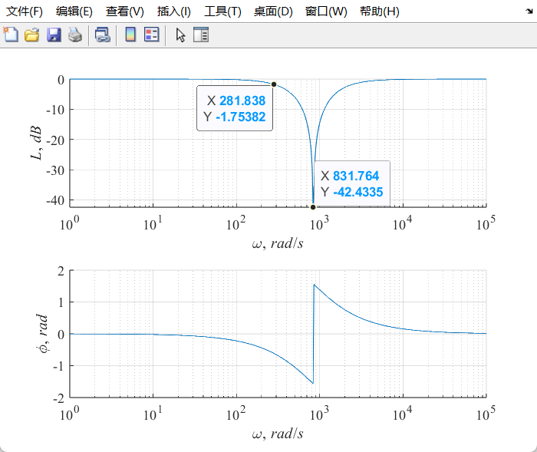

**Figure 3.** Frequency response.

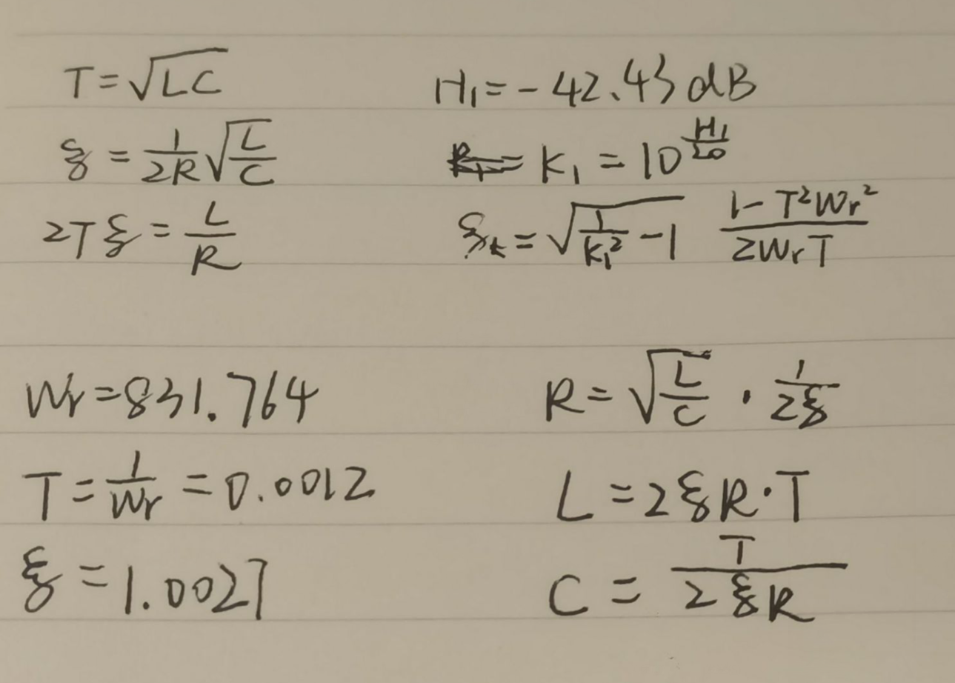

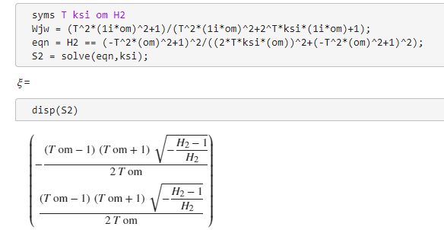

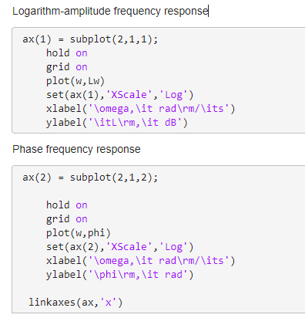

**7. Comparing of transients**

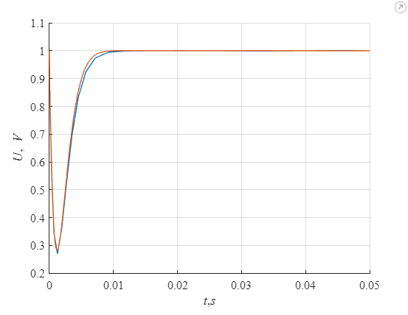

**Figure 4.** Simulation results of the state space model and the given transient response.

**8. Comparing of frequency responses.**

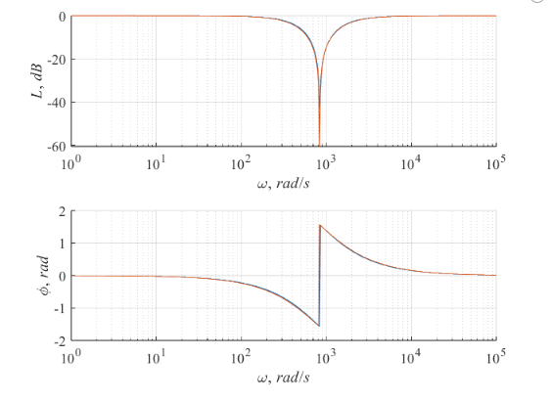

**Figure 5.** Given frequency response and frequency response received experimentally.

**9.Conclusion**

In this lab, we investigated the behavior of an electrical circuit by first constructing its model using Simscape. Based on the given component parameters, we derived a state-space representation of the system through a set of governing equations. From this model, the corresponding transfer function was obtained. Using frequency response analysis, we were able to estimate the circuit's key elements—resistance (R), inductance (L), and capacitance (C). Finally, we examined both the transient and frequency domain responses, observing a strong correlation between the two, which validated the accuracy of our model.